LETTER OF MOTIVATION SAMPLE FOR A MASTER IN MECHANICAL ENGINEERING

Name and Surname of the applicant
Applicant’s address
E-mail of the applicant

University [Name]
[School / faculty name]
Address
Admission office

Subject: Motivation letter for a Master program in Mechanical Engineering

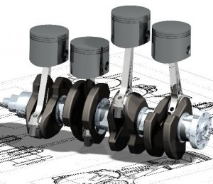
Dear Sirs, Madams,

I was very glad when I saw this particular opportunity to apply for a Master program in Mechanical Engineering and with this letter I would like to express my strong motivation for this master course. I am a graduate of the University Of Szeged, Hungary holding BSc degree in Mechanical engineering.

I have graduated with honors at University of Szeged where I was able to get a solid knowledge in the field. At the moment I am doing my internship in XXX Corp, where I am learning in practice how to apply methods for advanced component and structure dimensioning, which was the topic of my Bachelor thesis. Thanks to this particular experience I was able to perceive the complexity of this field, and to realize that I would like to develop my career in this area. Beside application of structure dimensioning, I hold especial interest in the digital design – both Computer aided design and computer aided engineering, and I would like to do specialization in this particular area.

After careful overview of the master program you are offering with at your University, I believe that curricula fully suits my intentions, and therefore I would like to get an opportunity to attend this program.
Due to my financial situation I was able to continue my studies in my country or abroad, since I am not in a position to finance my studies. Therefore, I will be very grateful to be provided with scholarship to improve my education and incent my career prospects. Knowledge gained on the studies at your University I see as an extraordinary career opportunity, and therefore I would be very glad if you could support my education with scholarship and to further inform me about any scholarship opportunity that may appear.

At the end I would like to point out that I am determined to make the most of this opportunity. I believe that being a student in your department would not only empower my career development, but would give me the framework to utilize my full potentials. Moreover I feel that as a Masters student at your University, I can benefit from the numerous challenging career opportunities.

Once again I am grateful for considering my application and I look forward to a favorable reply.

Sincerely,

